Information on tourist spots around Ojiya

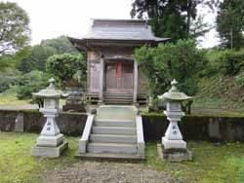
Ojiya Port

Ojiya port had great prosperity through ship transportation via the Shinano river. There was a security checkpoint at the port, and they inspected people, weapons and grains coming in and out. 10 to 20 ships came in and out a day, and those people who worked on the ships were busy going back and forth. The street by the port was lined with stores and full of people. There were a lot of tea-houses and the energetic voices of vendors welcoming people to come have their best tea and dango were to be heard all day long. 10 forwarding agents were in business at the time and many other businesses were run by the port, such as inns, couriers and rice warehouses.

Everyday ships going up the river bound for Tōkamachi carried commodities, such as sake, miso and salt. Ships going down the river bound for Niigata carried crops and products, such as rice, handcarts and sometimes Ojiya Chijimi.

Ships were towed by manpower using a rope made of hemp. For a large ship, 8 to 10 people were needed. January 11th was the first work day of the year. Although in the winter the water is ice-cold and the temperature of the atmosphere is subzero, they still had to get in the water and work.

It is said that the Shinano river used to flow further east of its current stream and the river beaches were wider.

